**CSE 310 Tic Tac Toc – The Modified Tic Tac Toe**

**Game Description:**

In Tic Tac Toc, the first player to force their opponent to complete three in a row wins. This is a 2-player game and each game will have either a winner or a draw.

**Brief Overview:**

We have finished 100% of the project, excluding all the extra credit. We implemented single game and multi game. The client and server python files **MUST** **be run on** **linux/unix** **systems that support ePoll (Windows does not support ePoll).** This game is programmed in Python 2.7.

**Single game functionality:**

- Commands: Help, Login, Place, Exit

- One of the major functionalities implemented is AutoPlay. AutoPlay automatically pairs

2 players on the server and starts a game. The player who logs in first will get to place his/her move first. When a game ends, the server will automatically start a new game between the 2 players. If only one player is on the server, he/she will be forced to wait for another player to log on.

- The single game server supports up to a maximum of 2 players.

**Multi game functionality:**

- Commands: Help, Login, Place, Exit, Games, Who, Play, whoami

- One of the major functionalities implemented is Play. Players will have the ability to

play another user on the server. Players will not be able to play themselves. AutoPlay is removed in multi game server.

- The multi game server supports an unlimited number of players and multiple players

until all resources on the machine is utilized.

# Single Game User Documentation:

The single game server only supports a maximum of 2 players and a maximum of 1 ongoing game at any time. To start, make sure you are on a **linux/unix system** **that supports ePoll (Windows does not support ePoll)** and that Python 2.7 is installed.

Instructions for setting up game:

1. Run “python singleServer.py” on a linux/unix environment. The default port is 9347.
2. Run “python singlePlayer.py serverIP 9347” on a linux/unix environment. This will set up the first client for the first player. You will need to repeat this step to set up for the second player.

Supported commands:

**help**

* + 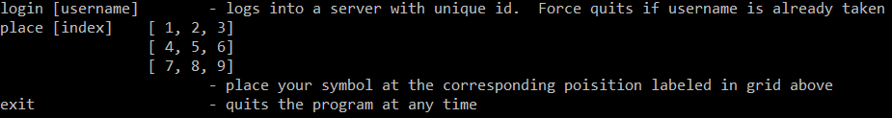Displays a help menu:

**login username**

* + Log into the server with *username* as user id
  + Possible successful messages:
    - “Please wait … searching for opponents”

You are the only player on the server right now.

* + - “Your opponent is: otherPlayerName”

The server has paired you with another player where otherPlayerName is your

opponent’s name.

A 3 by 3 board is also printed and all empty fields are shown with dots. The

player who logged in first will get to place their move first.

Picture of board: . . .

. . .

. . .

* + Possible error messages:
    - “Username has been taken, please enter another name:”  
      You are asked to use another username because the current username is in use.
    - “Username must not contain any spaces!”  
      Your username currently contains a space and spaces are not allowed. Only alphanumeric characters are allowed.

**place number**

* + Place a move on the game board at position *number*
  + You are only allowed to use numbers 1 to 9. The 3 by 3 game board is represented in the following numerical representation: 1 2 3  
     4 5 6  
     7 8 9
  + Possible successful messages:
    - X . .

. . .

. . .

If you are the first player, the game board will be printed with X at the position specified with the place command. In this case, it is “place 1”.

* + - . . .

O . .

. . .

If you are the second player, the game board will be printed with O at the position specified with the place command. In this case, it is “place 4”.

- Both players will see a board on their screen after a move is done.

- If there is a winner, winner of the game will be displayed and a new game will be automatically started.

- If it is a draw, both players will be notified that the game is a draw and a new game will be automatically started.

* + The error message “invalid move: number” is caused by one of the following:
    - It is currently not your turn to place a move
    - You tried to place a move on a spot that is already placed.
    - You used a number less than 0 or greater than 9 or your number is not an integer. The game board in numerical representation will be displayed on your screen to help you.

**exit**

* + You may type this command at any time to exit the client program.
  + If you are not in a game, the client program automatically exits.
  + If you are in a game, the following will happen:
    - The other player will be notified that you left the game and will be the winner of the game.
    - Your client program automatically exits.

# Multiple Game User Documentation:

The multiple game server supports as many players and ongoing games as permitted by hardware resources. To start, make sure you are on a **linux/unix system** **that supports ePoll (Windows does not support ePoll)** and that Python 2.7 is installed.

Instructions for setting up game:

1. Run “python multipleServer.py” on a linux/unix environment. The default port is 9347.
2. Run “python player.py serverIP 9347” on a linux/unix environment. This will set up the first client for the first player. You will need to repeat this step to set up for other players.

Supported commands:

**help**

* + 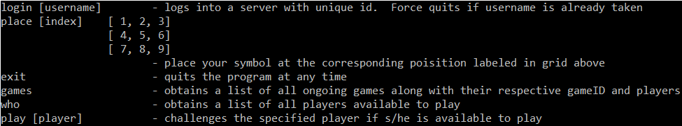Displays a help menu:

**login username**

* + Log into the server with *username* as user id
  + Possible successful messages:
    - “Logged in successfully at time: [Month Day Year CurrentTime]”

The message displays the date and current time of your successful login.

* + Possible error messages:
    - “Username has been taken, please enter another name:”  
      You are asked to use another username because the current username is in use.
    - “Username must not contain any spaces!”  
      Your username currently contains a space and spaces are not allowed. Only alphanumeric characters are allowed.

**place number**

* + Place a move on the game board at position *number*
  + You are only allowed to use numbers 1 to 9. The 3 by 3 game board is represented in the following numerical representation: 1 2 3  
     4 5 6  
     7 8 9
  + Possible successful messages:
    - X . .

. . .

. . .

If you are the first player, the game board will be printed with X at the position specified with the place command. In this case, it is “place 1”.

* + - . . .

O . .

. . .

If you are the second player, the game board will be printed with O at the position specified with the place command. In this case, it is “place 4”.

- Both players will see a board on their screen after a move is done.

- If there is a winner, winner of the game will be displayed and a new game will be automatically started.

- If it is a draw, both players will be notified that the game is a draw and a new game will be automatically started.

* + The error message “invalid move: number” is caused by one of the following:
    - It is currently not your turn to place a move
    - You tried to place a move on a spot that is already placed.
    - You used a number less than 0 or greater than 9 or your number is not an integer. The game board in numerical representation will be displayed on your screen to help you.

**exit**

* + You may type this command at any time to exit the client program.
  + If you are not in a game, the client program automatically exits.
  + If you are in a game, the following will happen:
    - The other player will be notified that you left the game and will be the winner of the game.
    - Your client program automatically exits.

**who**

* + You may type this command at any time when you are logged in to see user id of all available players, excluding yourself.
  + Possible output:
    - “No available users online!”
    - “Available users online: [list of all available player’s username]”

**games**

* + You may type this command at any time when you are logged in to see game id and players for each ongoing game.
  + Possible output:
    - “No games in progress!”
    - “Games in progress: [list of all ongoing games]”

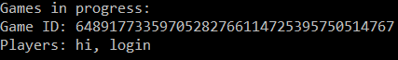Sample output:

**play username**

* + Challenges a player with a user id of username. The player being challenged must be available (not currently in a game).
  + Successful message sample:  
    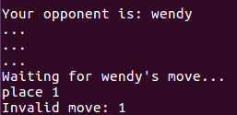
  + Possible error messages:
    - “Opponent [username] does not exist!”

You tried to play a non-existing player.

* + - “Opponent [username] is busy!”

You tried to play a player who is currently in a game.

**whoami**

* + Prints your username/user id. This is an extra functionality not required in specifications.
  + Successful message sample:  
    https://lh4.googleusercontent.com/jIokdz4y48iVr30sJstdi34Z9vJ1TuEE5PlJhGvmwDBxbeTWTD2MIN4KGYQve3IOjHr752GyO0beZEFxZIUb-sHIMAUT68s1Ph0IydtXoh1eyFyoIyo_2kxJRWkx9QXL7XnhyYa5
  + Possible error messages:  
    https://lh5.googleusercontent.com/ZxCovhoCNUEMoh5Y3IKA2ohF4WmlF6OnB8p5kRVNTnvhgCc0Ax-ImbWuZEeKnrVfBgwp1y4dU-hjx1Giz5P-mtjnG_jlM5zz3Eq_0EcWsMKnFdsLRcmV4npRE7_Lm4o9WMQFFhPZ

# System Documentation:

Source Code Files

board.py

Code for the functionality of the Tic Tac Toc game

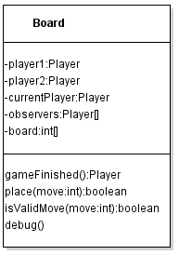

singleServer.py

Server that handles only 1 ongoing game and maximum of 2 players.

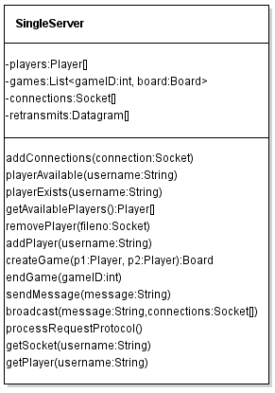

multiServer.py

Server that handles multiple ongoing games and unlimited players.

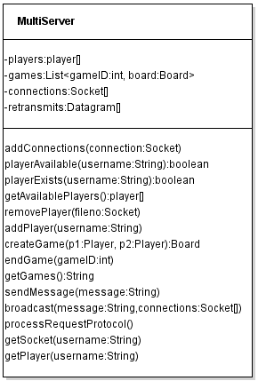

singlePlayer.py

Client for singleServer.py

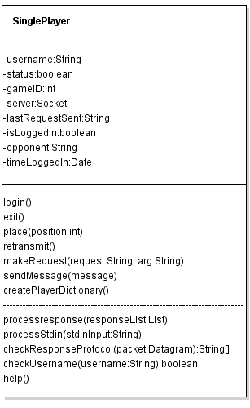

player.py

Client for multiServer.py

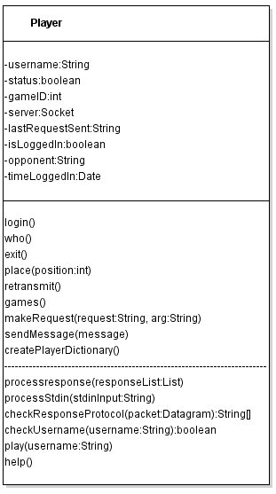

jaw_enums.py

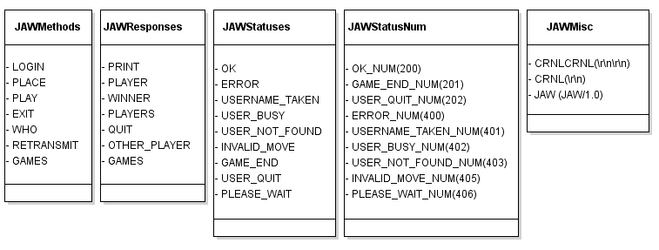Contains variables and all information about the JAW protocol

Changing Server Port

Default Single/Multiple Game Server Port: 9347

To change the server port for single/multiple game server, edit the *serverPort* variable in the source code.

Client Server Communication Protocol Diagram

Protocol diagram for player quitting:

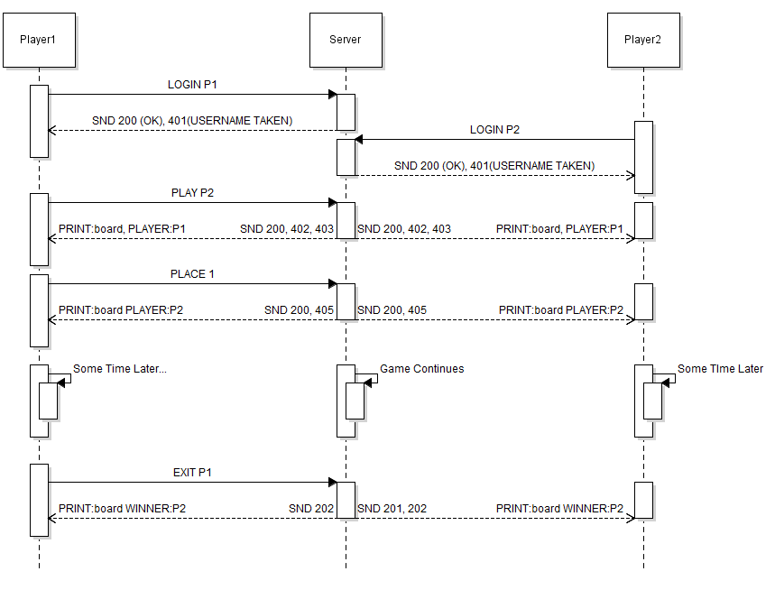

Protocol diagram for single game server:

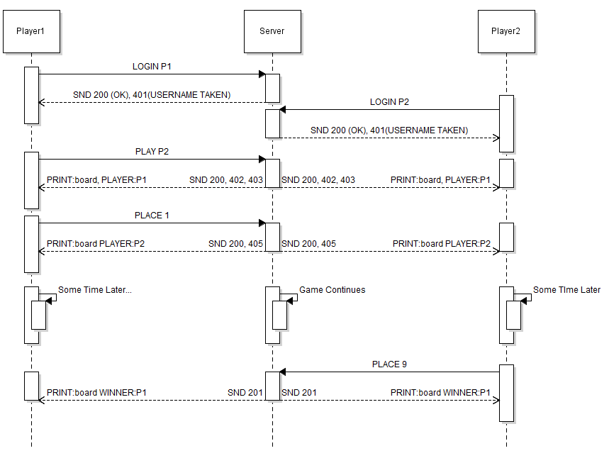

Protocol diagram for multiple game server:

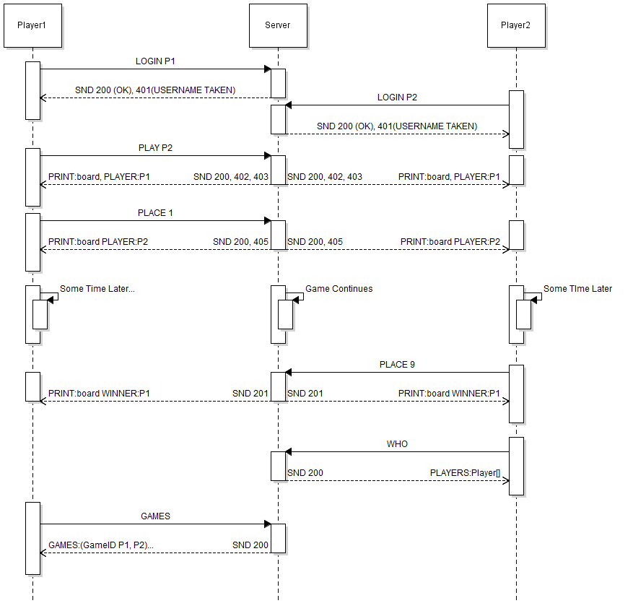

Concurrency

We did not use multi-threading in this project. We used ePoll which is Linux/Unix specific and is part of select. ePoll is a very efficient technology for multiplexing I/O.

Major Data Structures

The 2 major data structures used in this project are list and dictionary in Python 2. By utilizing key value pairs in a dictionary, we are able to have fast operations improving the speed of the server. The game board is stored in a list which allows ease of use when a player places a move.

Important Algorithms

Because TCP packets can be lost, we implemented retransmit in server and client files. It is possible for clients to receive an empty packet because we are using ePoll to multiplex I/O. When a client receives an empty packet, it asks the server for a retransmission to receive the data again. The server stores the most recent message of each client’s action. If the client’s action requires several messages to be sent consecutively from the server, those consecutive messages are stored and counted as one retransmission.

Debugging/Log Output

All client and server python files come with logging/debugging functionality. The server logs all received requests and sent responses with a timestamp. The client logs all sent requests, received responses, and parsed responses. All logging/debugging are turned off by default.

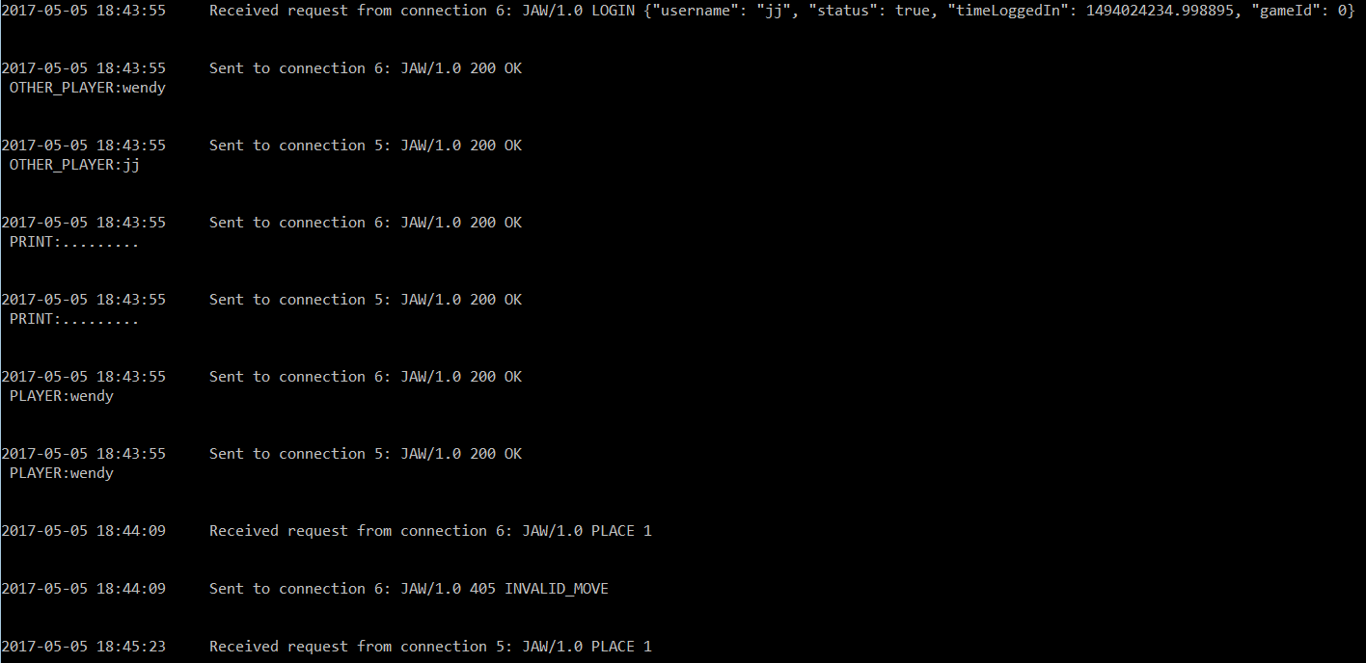Sample Server Log

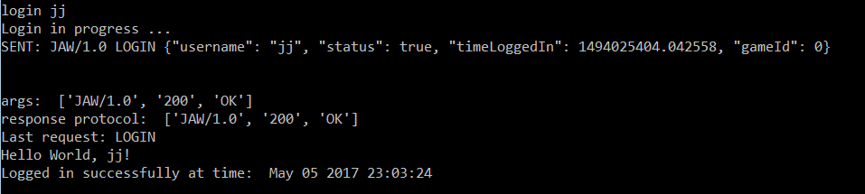Sample Client Log (with regular output)

To turn on/off logging/debugging:

1. Look for the debug variable in the main method.  
   
2. Set debug to True to turn on debugging. Otherwise, set debug to False.

Adding/Editing/Removing server functionalities

To add a new server functionality such as more commands:

1. Open the correct python server file in an editor of your choice. singleServer.py for single game and multServer.py for multiple game.
2. Define new functions as necessary in the Server class
3. Add a new *elif* clause in the function *processRequestProtocol()* located in the server class
4. To add new instance/class variables, add the variables in the _ _init_ _ function in the Server class.

To edit an existing server functionality such as a command:

1. Go to the correct python server file. singleServer.py for single game and multServer.py for multiple game.
2. Go to the function *processRequestProtocol()* located in the Server class.
3. Look for the corresponding *elseif* or *if* clause in *processRequestProtocol()* and edit the code inside. If there are function(s) called inside the clause, edit the called function(s) to achieve desired functionality without impacting other functionalities.
4. To edit existing instance/class variables, edit the variables in the _ _init_ _ function in the Server class.

To remove an existing server functionality such as a command:

1. Open the correct python server file in an editor of your choice. singleServer.py for single game and multServer.py for multiple game.
2. Go to the function *processRequestProtocol()* located in the Server class.
3. Look for the corresponding *elseif* or *if* clause in *processRequestProtocol()* and remove the clause. If there are function(s) called inside the clause, you may remove the called function(s) as long as they do not impact other functionalities.
4. To remove existing instance/class variables, remove the variables in the _ _init_ _ function in the Server class.

Changing Tic Tac Toc gameplay

1. Open board.py in an editor of your choice.
2. To add/edit/remove instance/class variables, look in the _ _init_ _ function in the Board class.
3. To change the winning conditions of the game, edit the *gameFinished()* function in the Board class.
4. To change how placing a move works, edit *place()* and *isValidMove()* functions in the Board class.
5. DO NOT change the _ _str_ _ function in the Board class.

Adding/Editing/Removing client functionalities:

1. Open the correct python client file in an editor of your choice. singlePlayer.py for single game and player.py for multiple game.
2. To add new/edit/remove instance/class variables, look in the _ _init_ _ function in the Player class.
3. To add client command, edit *processStdin()* and *processResponse()*. Add new functions in Player class as needed.
4. To edit client command, edit *processStdin()* and *processResponse()*. Edit the corresponding functions to the command you want to edit in Player class as needed.
5. To remove client command, edit *processStdin()* and *processResponse()*. Remove the corresponding functions to the command you want to remove in Player class without altering other client functionalities.
6. DO NOT change the _ _str_ _ function in the Player class.

Error Conditions

* USERNAME_TAKEN with status code 401  
  This happens when a player tries to log onto the server with an existing user id/username.  
  Player will have to log in with another username.
* USER_BUSY with status code 402  
  This happens when a player tries to play another player who is in a game  
  Player will have to play an available player found from WHO command.
* USER_NOT_FOUND with status code 403  
  This happens when a player tries to play a non-existing player.  
  Player will have to play an available player found from WHO command.
* INVALID_MOVE with status code 405  
  This happens when a player tries to play when it is not his/her turn, tries to place a move at a position less than 0 or greater than 9, or tries to place a move on a position that already contains a move.  
  Player will have to place move at his/her turn with a valid position.
* ERROR with status code 400  
  This happens when a player performs an unsupported operation that is not listed above. These errors are not important enough to have their own error status code and message. For single server, this includes when a player tries to log onto a server that has 2 players.  
  Player will be notified something has gone wrong and will need to retry their last action.

Generating/Compiling Executables

By running “python fileName.py”, Python will automatically compile and run the python code. A pyc file will be created in the same directory as the py files for all imported py files. The pyc file contains byte code which is the Python compiled version of the source (py) code.

# Testing the Player (Client) Program

## Starting the Player (Client) Application

* Running with wrong arguments



* Running with missing arguments



* Running without arguments, missing arguments, wrong arguments

Screenshot from 2017-05-05 18-14-16.png

* Running with correct arguments, place without logging in

2.png

* Single and MultiPlayer/Server
* Username Taken

First user: 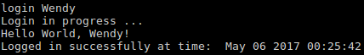

Other user: 

* Single Player/Server
* Running with correct arguments and login successful (no users online)

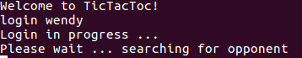

* Running with correct arguments and login successful (autoplay)

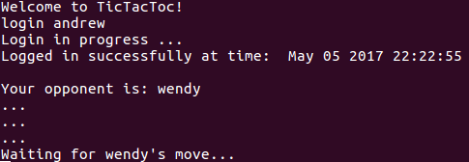

* Multiplayer/Server
* Running with correct arguments and login

## Playing a Game

* Single and MultiPlayer/Server
* Placing a move when not player turn

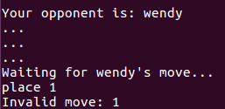

* Placing a move when player turn (valid)

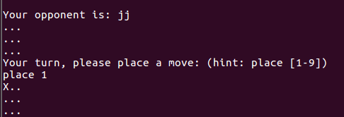

* Placing a move when player turn (invalid)

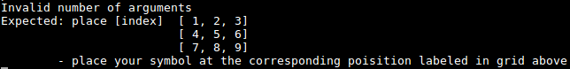

## Winning, Losing and Drawing Games

* Single and MultiPlayer/Server
* Winning/Losing

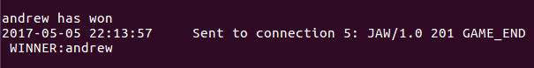

* Draw

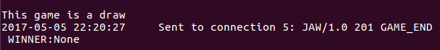

* User Quit

## 

## List of Ongoing Games

* MultiPlayer/Server
* No games in progress



* Games in progress

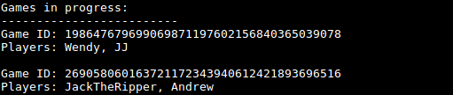

## List of Available Players Online

* MultiPlayer/Server
* No available players online



* Players online



## Playing Specific Player

* MultiPlayer/Server
* User does not exist



* User is busy



* User is available

First user: 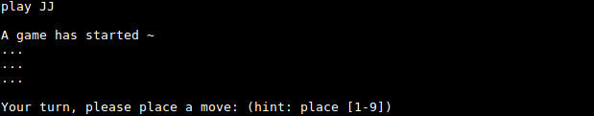

Opponent: 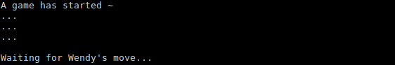

**Who Am I?**

* MultiPlayer/Server
* Who am I (logged in)

https://lh4.googleusercontent.com/jIokdz4y48iVr30sJstdi34Z9vJ1TuEE5PlJhGvmwDBxbeTWTD2MIN4KGYQve3IOjHr752GyO0beZEFxZIUb-sHIMAUT68s1Ph0IydtXoh1eyFyoIyo_2kxJRWkx9QXL7XnhyYa5

* Who am I (not logged in)

https://lh5.googleusercontent.com/ZxCovhoCNUEMoh5Y3IKA2ohF4WmlF6OnB8p5kRVNTnvhgCc0Ax-ImbWuZEeKnrVfBgwp1y4dU-hjx1Giz5P-mtjnG_jlM5zz3Eq_0EcWsMKnFdsLRcmV4npRE7_Lm4o9WMQFFhPZ

## Exiting the Player (Client)

* Single Player/Server
* Exiting when in middle of game

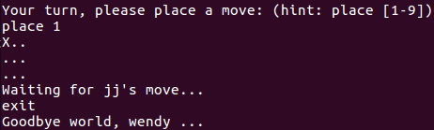

* Exiting when searching for opponents

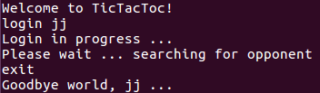

* Exiting prior to login



## Help

* Single and MultiPlayer/Server
* Help when in middle of game

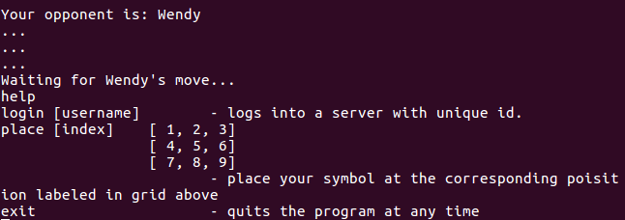

* Help when searching for opponents

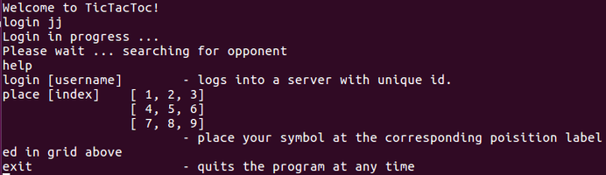

* Help prior to login

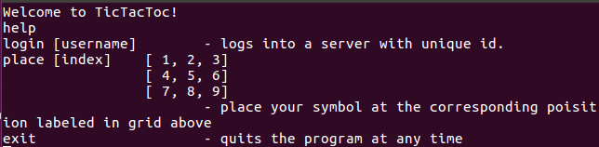

# Testing the Server Program

## Starting the Server Application

* Single and MultiPlayer/Server
* Login successful

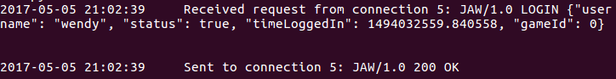

* Login username taken

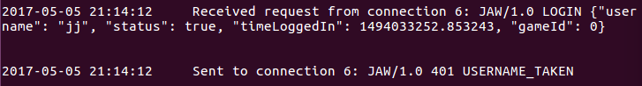

## Playing a Game

* Single and MultiPlayer/Server
* Broadcast Board and Play

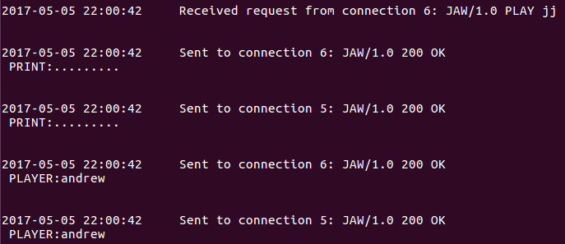

## List of Ongoing Games

* MultiPlayer/Server
* No games in progress

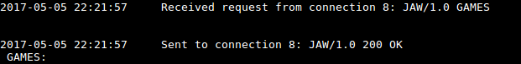

* Games in progress

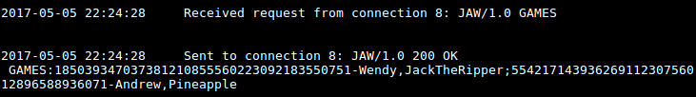

## List of Available Players Online

* MultiPlayer/Server
* No available players online

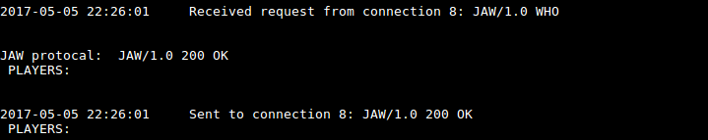

* Players online (from a free player)

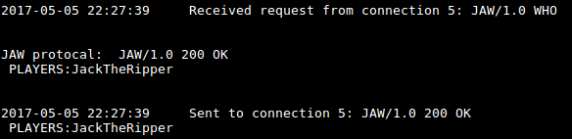

* Players online (from a in-game player)

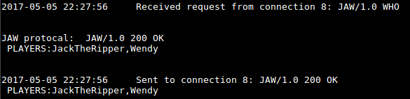

## Playing Specific Player

* MultiPlayer/Server
* User is available

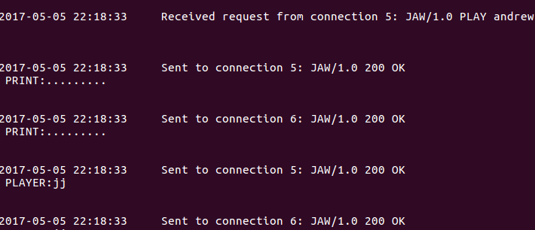

* User is busy

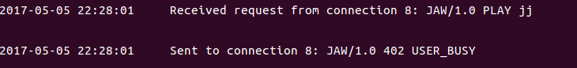

* User is does not exist

